February 23, 2009 Town of Mount Pleasant Board of Zoning Appeals.
Property owner Catherine Templeton, who owns a home two doors down from the I’On Creek Club, has appealed Zoning Administrator Joel Ford’s decision that the Creek Club is a civic use. 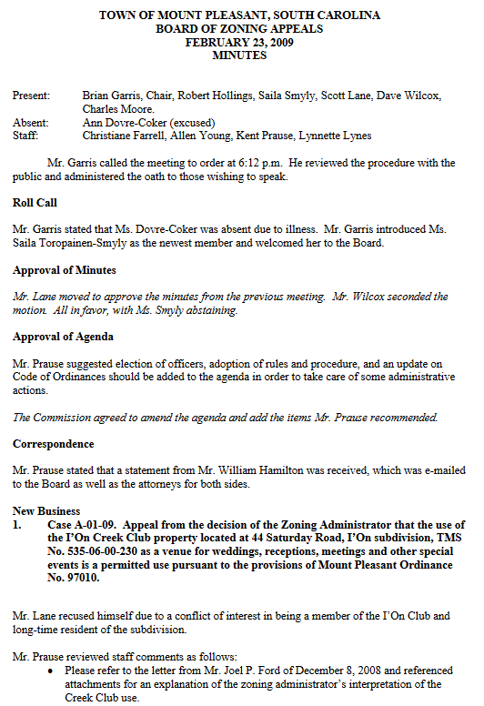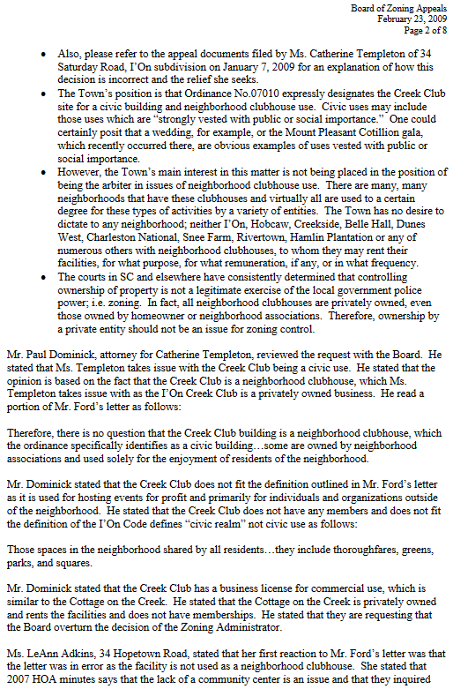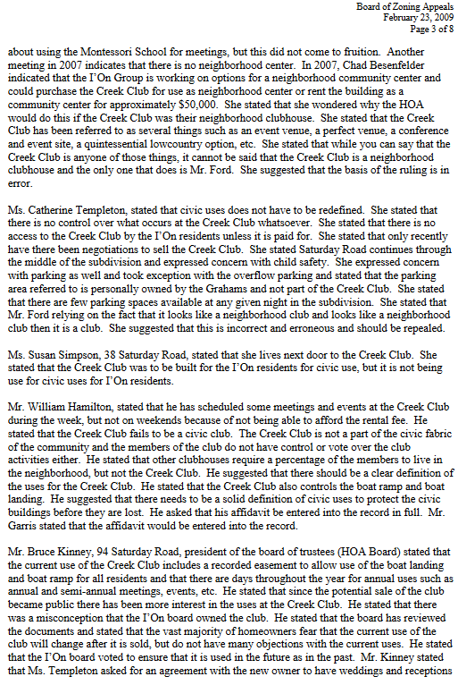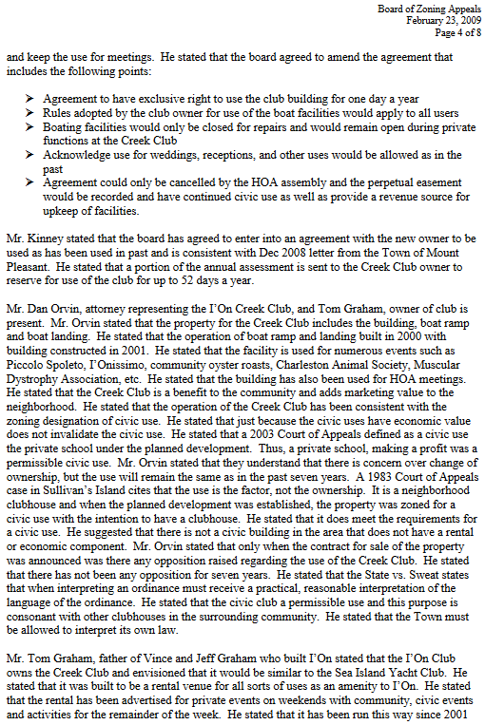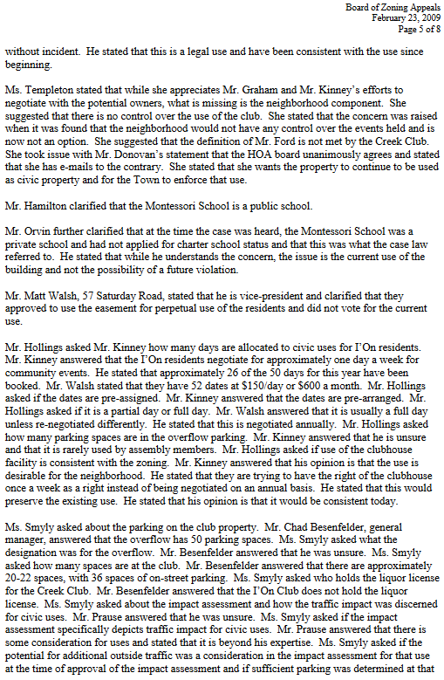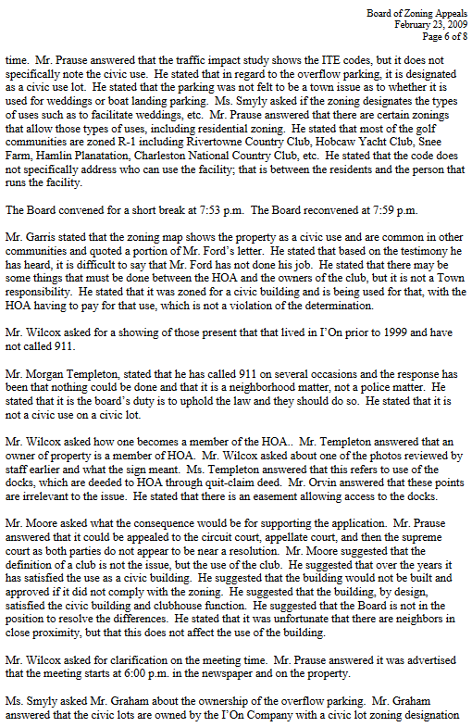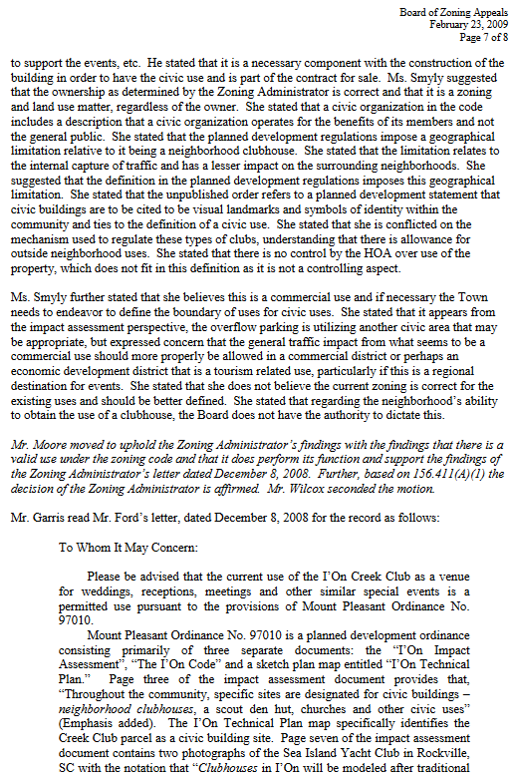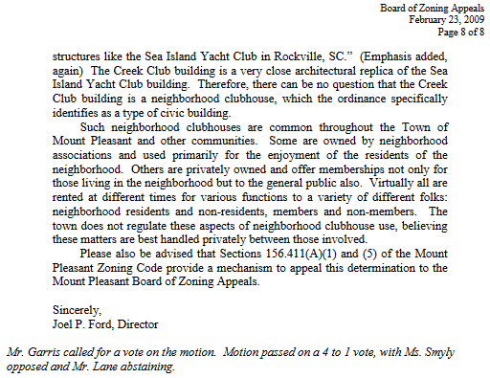

The following day, February 24, 2009, I’On resident Ward Mundy emails Lea Ann Adkins, Steve Brock, Mary Mundy, Catherine Templeton, and Laurie Thornhill with his thoughts on the Board of Zoning Appeals 4-1 vote to sustain Zoning Administrator Ford’s decision. In this email, Mundy suggests a legal strategy that Lea Ann Adkins and Brad Walbeck will useto bring suit against the I’On Company.
